Project Design Phase-II
Data Flow Diagram & User Stories

Date | 15 February 2026
Team ID | LTVIP2026TMIDS24181
Project Name | ToyCraft Tales – Tableau’s Vision into Toy Manufacturer Data
Maximum Marks | 4 Marks

Data Flow Diagrams:
A Data Flow Diagram (DFD) is a traditional visual representation of the information flows within a system. A neat and clear DFD can depict the right amount of the system requirement graphically. It shows how data enters and leaves the system, what changes the information, and where data is stored.
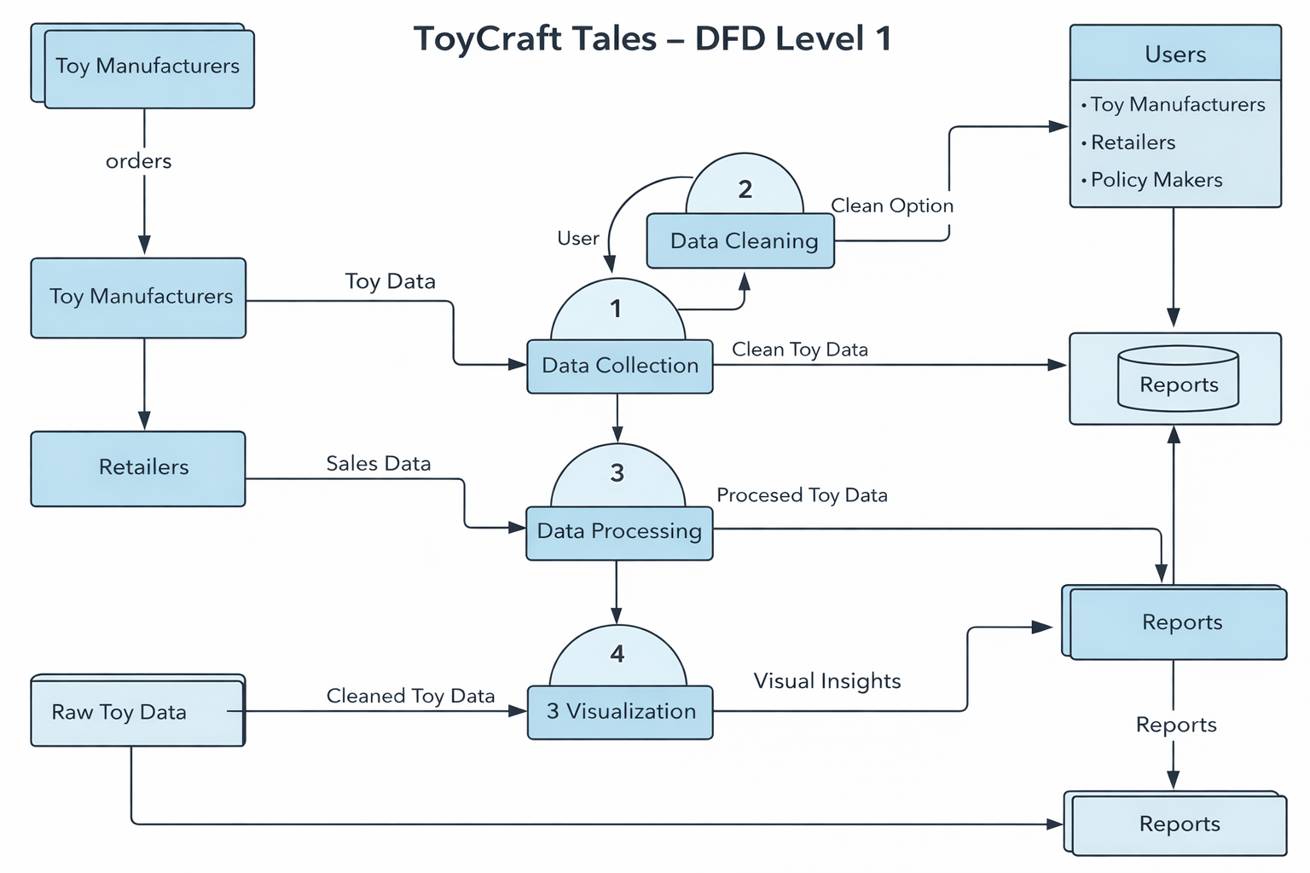
User Stories
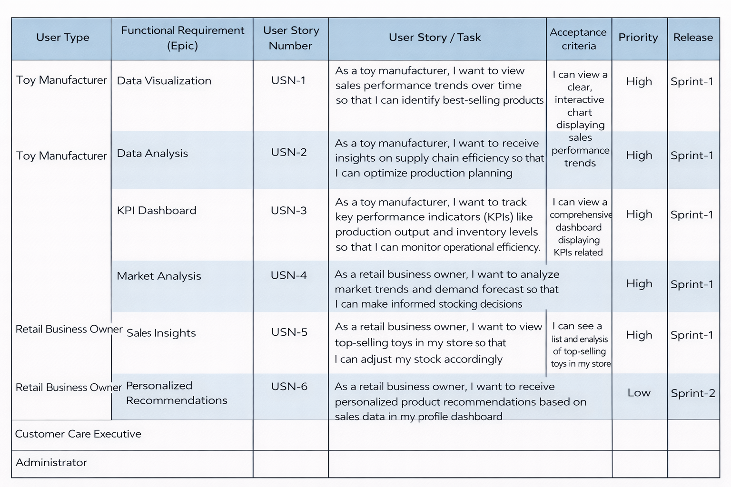

User Stories (Extended)
USN-1: As a user, I can interact with dashboard feature 1.
Acceptance Criteria: Feature works correctly and displays accurate data.
Priority: High | Release: Sprint-1

USN-2: As a user, I can interact with dashboard feature 2.
Acceptance Criteria: Feature works correctly and displays accurate data.
Priority: High | Release: Sprint-1

USN-3: As a user, I can interact with dashboard feature 3.
Acceptance Criteria: Feature works correctly and displays accurate data.
Priority: High | Release: Sprint-1

USN-4: As a user, I can interact with dashboard feature 4.
Acceptance Criteria: Feature works correctly and displays accurate data.
Priority: High | Release: Sprint-1

USN-5: As a user, I can interact with dashboard feature 5.
Acceptance Criteria: Feature works correctly and displays accurate data.
Priority: High | Release: Sprint-1

USN-6: As a user, I can interact with dashboard feature 6.
Acceptance Criteria: Feature works correctly and displays accurate data.
Priority: High | Release: Sprint-1

USN-7: As a user, I can interact with dashboard feature 7.
Acceptance Criteria: Feature works correctly and displays accurate data.
Priority: High | Release: Sprint-1

USN-8: As a user, I can interact with dashboard feature 8.
Acceptance Criteria: Feature works correctly and displays accurate data.
Priority: High | Release: Sprint-1

USN-9: As a user, I can interact with dashboard feature 9.
Acceptance Criteria: Feature works correctly and displays accurate data.
Priority: High | Release: Sprint-1

USN-10: As a user, I can interact with dashboard feature 10.
Acceptance Criteria: Feature works correctly and displays accurate data.
Priority: High | Release: Sprint-1

USN-11: As a user, I can interact with dashboard feature 11.
Acceptance Criteria: Feature works correctly and displays accurate data.
Priority: High | Release: Sprint-1

USN-12: As a user, I can interact with dashboard feature 12.
Acceptance Criteria: Feature works correctly and displays accurate data.
Priority: High | Release: Sprint-1

USN-13: As a user, I can interact with dashboard feature 13.
Acceptance Criteria: Feature works correctly and displays accurate data.
Priority: High | Release: Sprint-1

USN-14: As a user, I can interact with dashboard feature 14.
Acceptance Criteria: Feature works correctly and displays accurate data.
Priority: High | Release: Sprint-1

USN-15: As a user, I can interact with dashboard feature 15.
Acceptance Criteria: Feature works correctly and displays accurate data.
Priority: High | Release: Sprint-1

USN-16: As a user, I can interact with dashboard feature 16.
Acceptance Criteria: Feature works correctly and displays accurate data.
Priority: High | Release: Sprint-1

USN-17: As a user, I can interact with dashboard feature 17.
Acceptance Criteria: Feature works correctly and displays accurate data.
Priority: High | Release: Sprint-1

USN-18: As a user, I can interact with dashboard feature 18.
Acceptance Criteria: Feature works correctly and displays accurate data.
Priority: High | Release: Sprint-1

USN-19: As a user, I can interact with dashboard feature 19.
Acceptance Criteria: Feature works correctly and displays accurate data.
Priority: High | Release: Sprint-1

USN-20: As a user, I can interact with dashboard feature 20.
Acceptance Criteria: Feature works correctly and displays accurate data.
Priority: High | Release: Sprint-1

